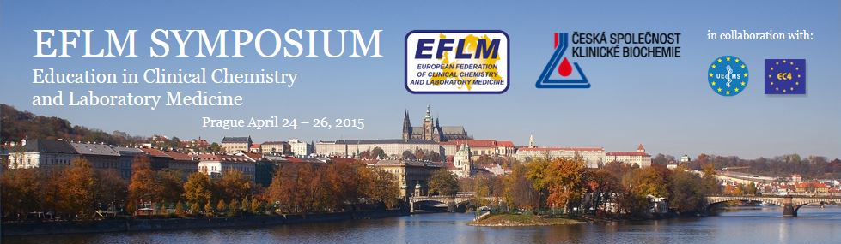

Please send this form by March 15, 2015 to:


Symposium Secretariat
Congress Business Travel, Ltd. (CBT) Phone: +420 224 942 575, 224 942 579
Lidická 43/66 Fax: +420 224 942 550
150 00 Prague 5, Czech Republic E-mail: educationprague2015@cbttravel.cz

All the information about offered hotels, location and distance to symposium venue you can find at symposium website at www.educationprague2015.cz

A C C O M M O D A T I O N B O O K I N G F O R M

Family name _________________________________________First name_____________________________

Title _______________________________________________________________________ Mr. / Ms

Street _______________________________________________City / Town ____________________________

Post / ZIP Code ______________________________________Country/State___________________________

Phone _________________________________________ Fax _______________________________________

E-mail ____________________________________________________________________________________

Accompanying person/s ______________________________________________________________________

H O T E L S

Accommodation has been booked at following hotels of different categories. Prices are given in EUR per night and room incl. breakfast, VAT and city tax. Kindly mark you choice carefully.

Arrival date________________ Departure date__________________ Number of nights: ____________

HOTEL | single room | double room | number of rooms
Novotel**** | 125 | 130
Ibis *** | 95 | 105
Crystal **** | 90 | 90
Legie *** | 70 | 80
Adante *** | 70 | 80

In case I request a double room/ twin bedded room/other request:

___________________________________________________________________________________

Upon receipt of the completed accommodation form CBT will send you the confirmation of the respective hotel together with the cancellation conditions.

PAYMENT

Please indicate which of the following methods you will use for the payment.

- bank transfer (please enclose a copy of the transfer to the form)
account name: Congress Business Travel account no: 1717936273
bank code: 0800 bank name: Česká spořitelna a.s.
bank address: Václavské nám. 16 , Prague 1, Czech Republic
IBAN CZ4908000000001717936273 SWIFT: GIBA CZ PX

All bank fees must be paid by remitter.

- please charge my credit card (+2% for administration fees):

Type : Visa □ Amex □ EuroCard/MasterCard □

Card Holder´s Name____________________________________________

Card No. __________________________________________________________________________________

Expiry Date (mm/yy)________________ CVV/CVC code _____________(last 3 digits on the signature panel)

Billing Address (AMEX):________________________________________________________________________

Date:___________________________________ Signature:__________________________________

All requests will be considered on first come first served basis. Should the hotel of your choice not be available any more, we will offer you a similar hotel instead.

